ECS - ELASTIC CONTAINER SERVICE TASKS

Internet → Application Load Balancer → ECS Service → 6+ ECS Tasks → Docker image sabair0509/hiring-app:works
For the requirement dynamic port mapping, use ECS on EC2 with bridge network mode. In bridge mode, leaving hostPort empty/0 causes ECS/Docker to dynamically assign an available host port, and ECS registers that port with the load balancer.
Important: Fargate uses awsvpc, where hostPort is the same as containerPort, so it does not provide the classic dynamic host-port mapping requested in this task.
ECS Highly Available Setup — Required Steps Only
Architecture
Use 2 Availability Zones:
Internet
|
|
Application Load Balancer
/ \
AZ-1 AZ-2
| |
ECS EC2 Instance ECS EC2 Instance
| |
┌─────┴─────┐ ┌─────┴─────┐
│ Task 1 │ │ Task 4 │
│ Task 2 │ │ Task 5 │
│ Task 3 │ │ Task 6 │
└───────────┘ └───────────┘
ECS Service
Desired = 6
ECS can maintain the desired task count and replace failed tasks automatically. AWS also supports Availability Zone rebalancing to distribute tasks across AZs.

STEP 1 — Create VPC
Go to:
AWS Console → VPC → Create VPC
Create:
- VPC CIDR: 10.0.0.0/16
- 2 Availability Zones
Create 4 subnets:
AZ-1
- Public subnet: 10.0.1.0/24
- Private subnet: 10.0.2.0/24
AZ-2
- Public subnet: 10.0.3.0/24
- Private subnet: 10.0.4.0/24
You need at least two AZs for the highly available design.

STEP 2 — Internet Gateway
Go to:
VPC → Internet Gateways → Create Internet Gateway
Name:
ecs-igw
Attach it to your VPC.

STEP 3 — Public Route Table
Create:
ecs-public-rt
Add route:
Destination: 0.0.0.0/0
Target: Internet Gateway
Associate it with:
10.0.1.0/24
10.0.3.0/24
These will be your public subnets.

STEP 4 — Create ECS Security Groups
You need two security groups.
ALB Security Group
Name:
ecs-alb-sg
Inbound:
HTTP TCP 80 0.0.0.0/0
Outbound:
All traffic

Step: 5 ECS Instance Security Group
Name:
ecs-instance-sg
Inbound:
HTTP TCP 80 from ecs-alb-sg
For dynamic port mapping, the ALB needs to reach the dynamically assigned host ports. Therefore, for this lab setup, allow the ephemeral port range from the ALB security group:
TCP 32768-65535
Source: ecs-alb-sg
Outbound:
All traffic
AWS documents that dynamic bridge-mode ports are selected from the host's ephemeral port range.

STEP 6 — Create ECS Cluster
Go to:
ECS → Clusters → Create cluster
Select:
Amazon EC2 instances
Cluster name:
hiring-ecs-cluster
For the EC2 capacity:
Desired capacity: 2
Minimum: 2
Maximum: 2
Use instances in two AZs.
For a lab, you can use:
t3.small
or
t3.medium

STEP 7 Create IAM Roles
ECS Instance Role
• IAM → Create Role → AWS Service → EC2
• Attach: AmazonEC2ContainerServiceforEC2Role
• Name: ecsInstanceRole
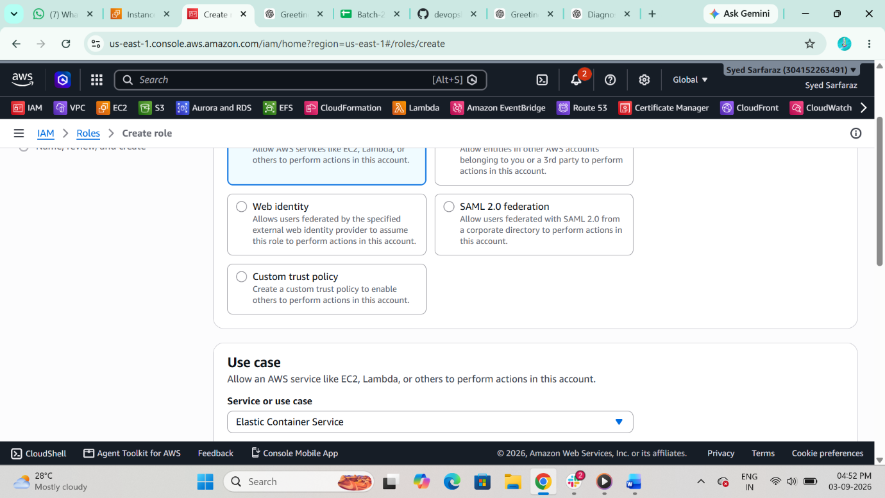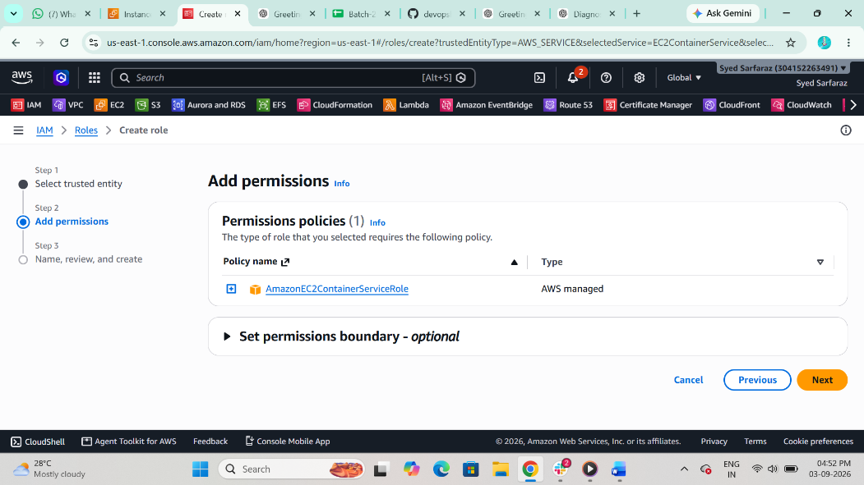

STEP 8 ECS Task Execution Role
• IAM → Create Role → AWS Service → ECS Task
• Attach: AmazonECSTaskExecutionRolePolicy
• Name: ecs-task-execution
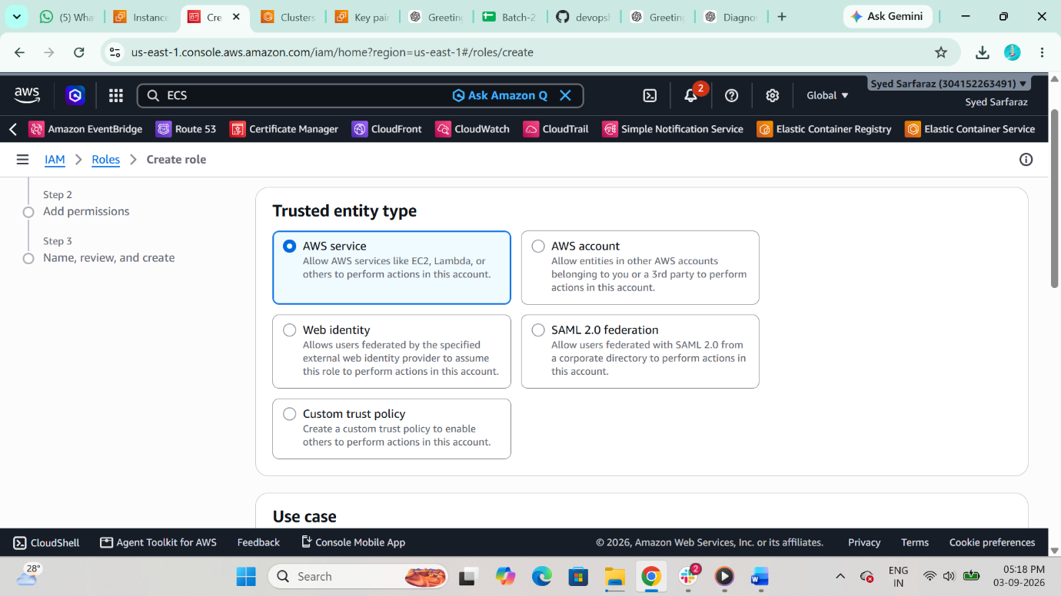
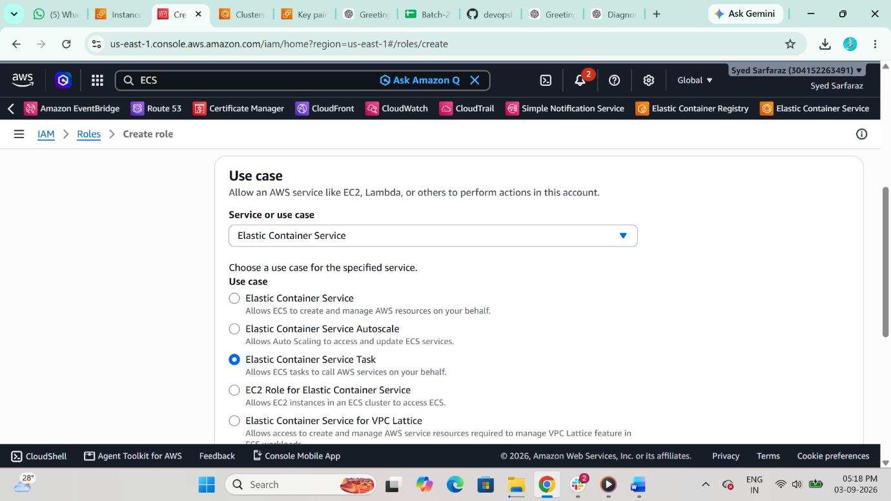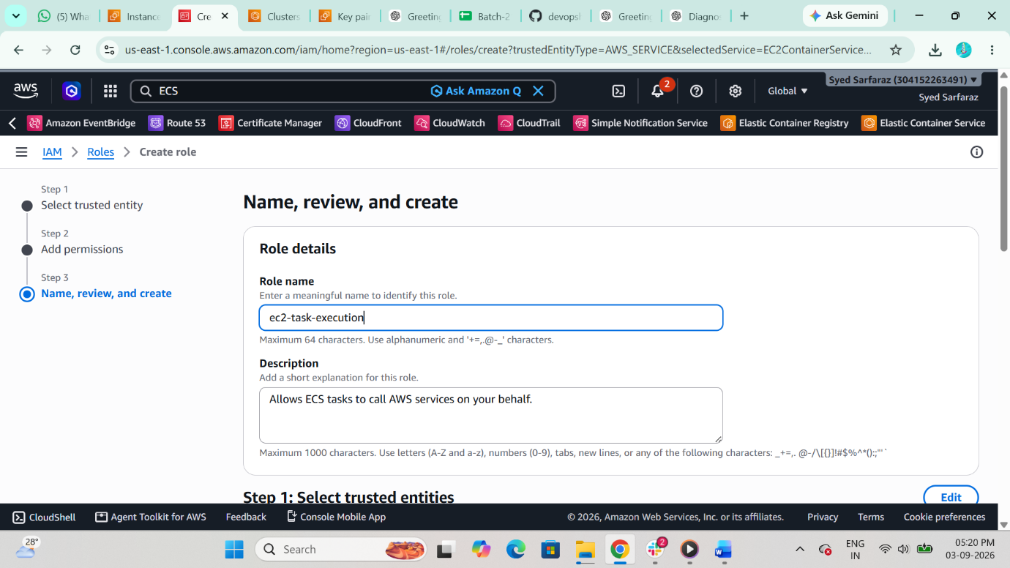

STEP 9 Create ECS Cluster (EC2)
• ECS → Create Cluster → EC2 Instances
• Cluster name: hiring-app-cluster
• Instance type: t3.large
• Min: 2 instances
• Max: 6
• Instance role: ecsInstanceRole
Ensure instances launch in multiple AZs
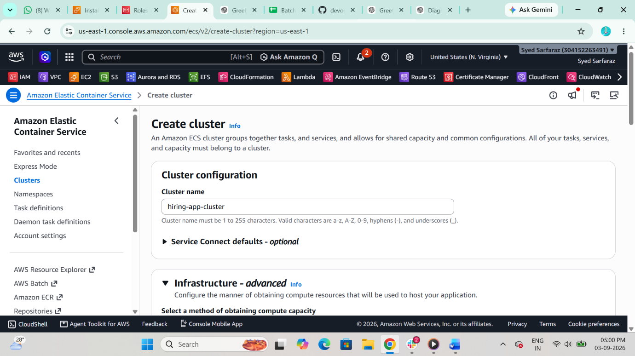
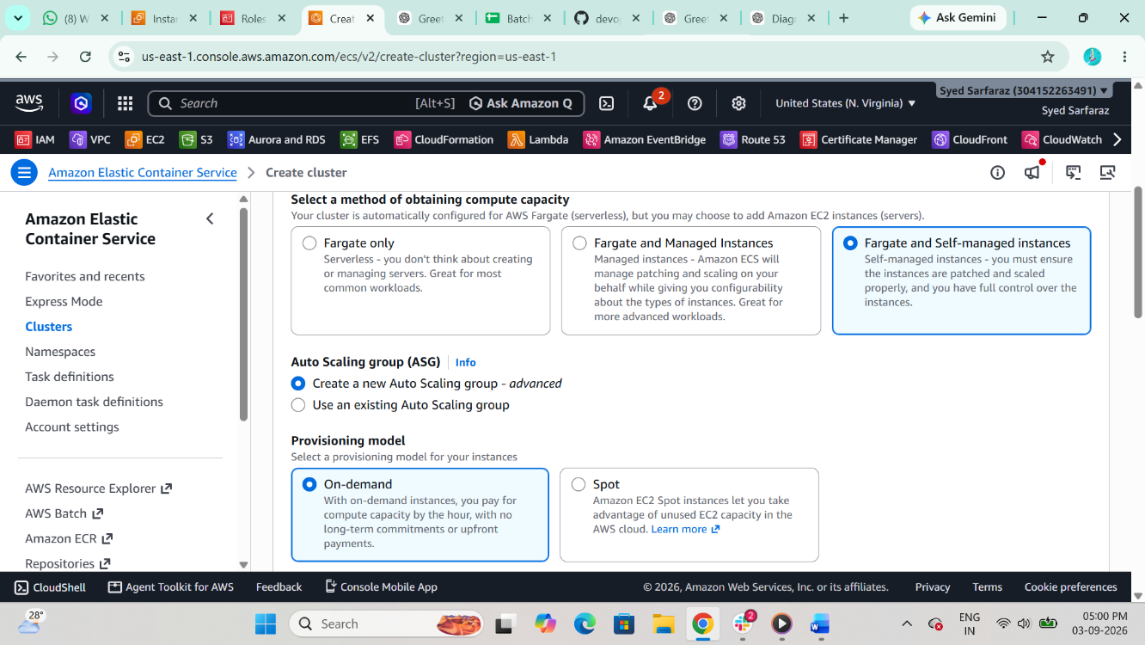
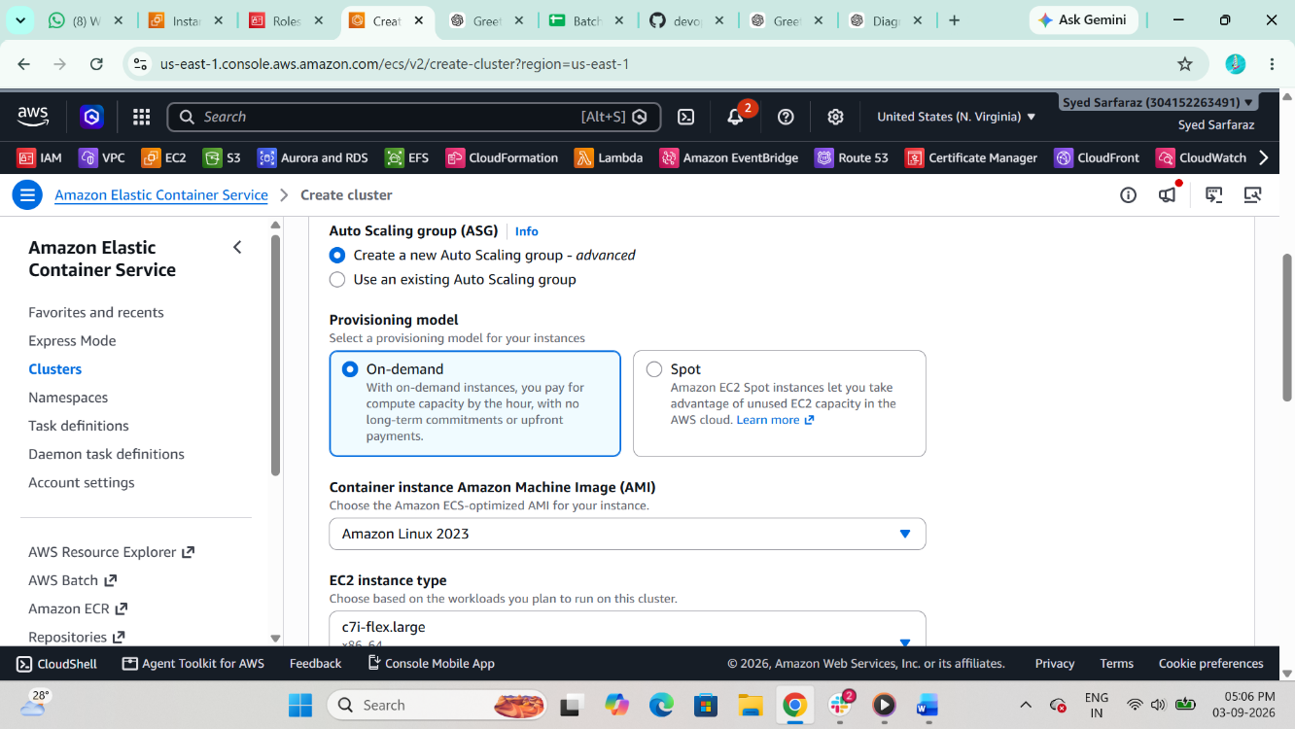
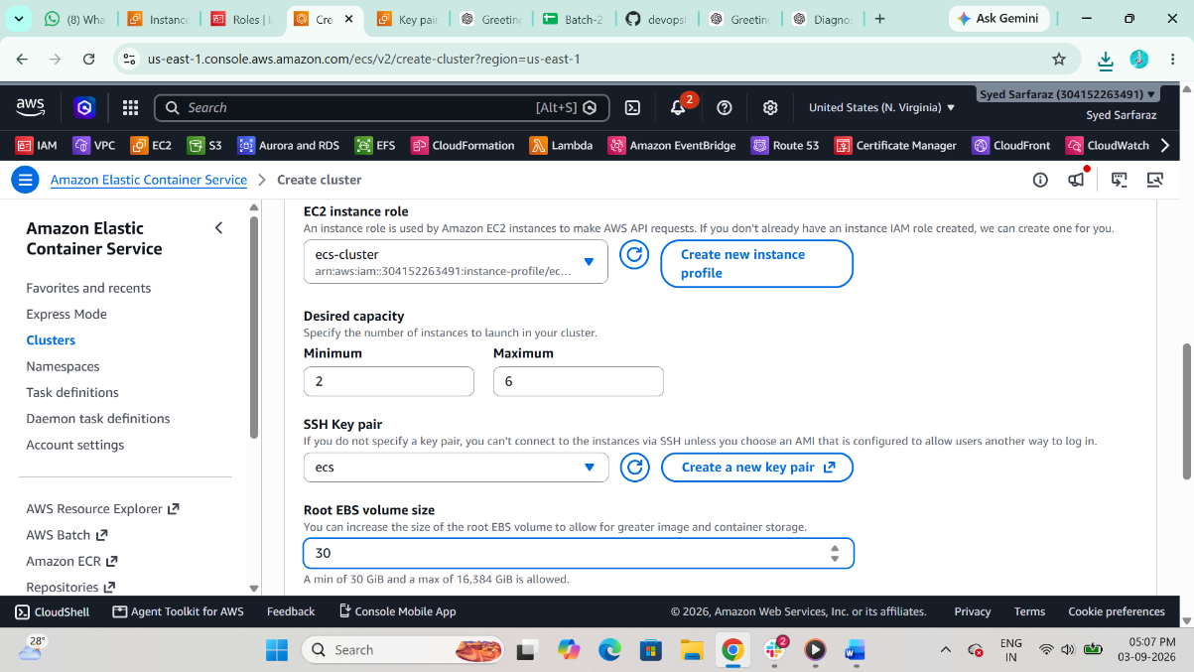
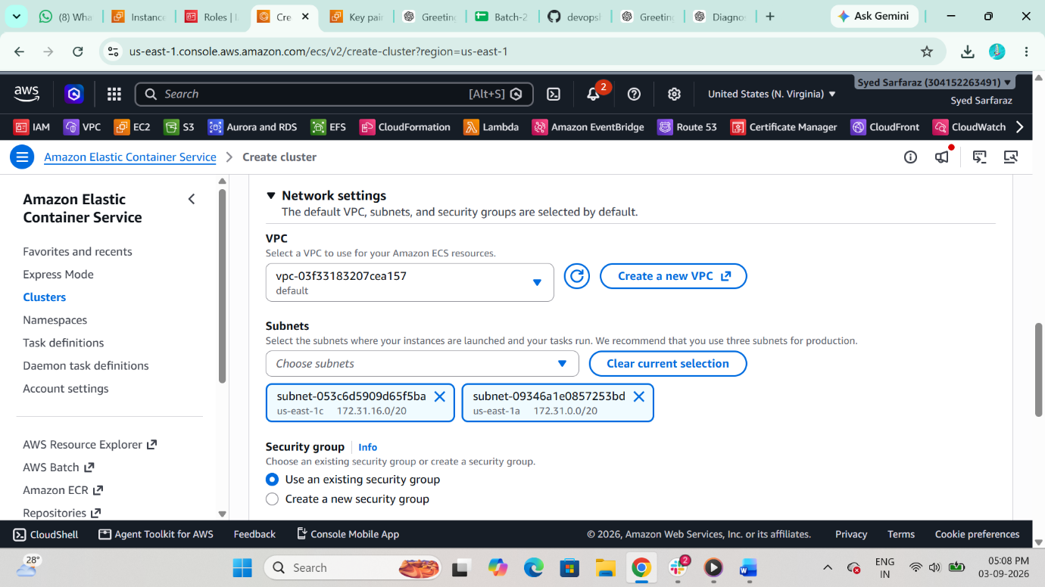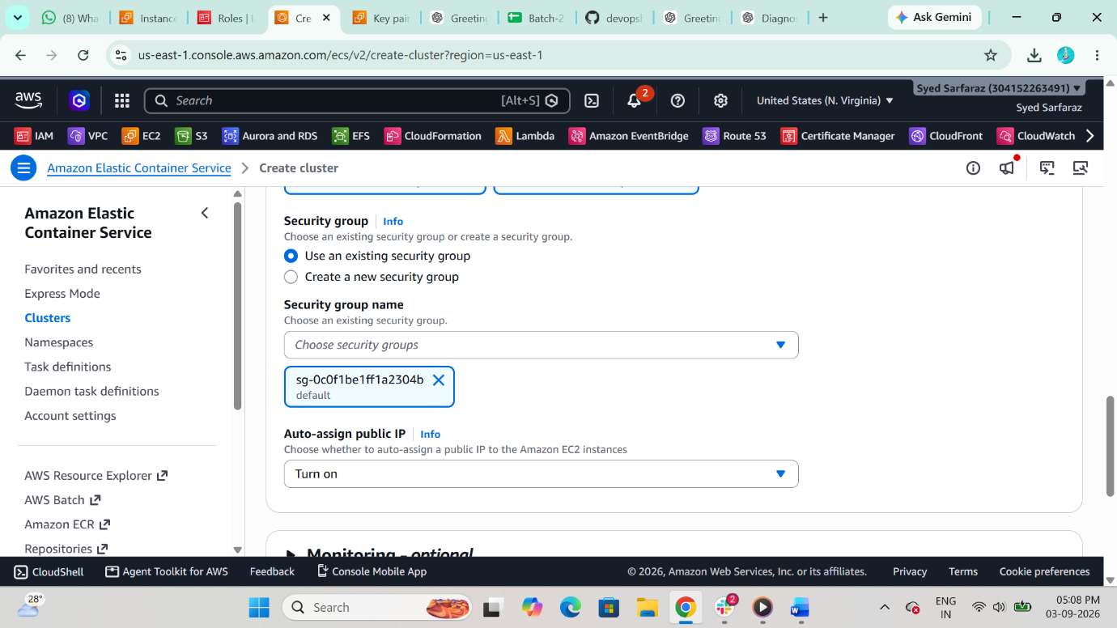
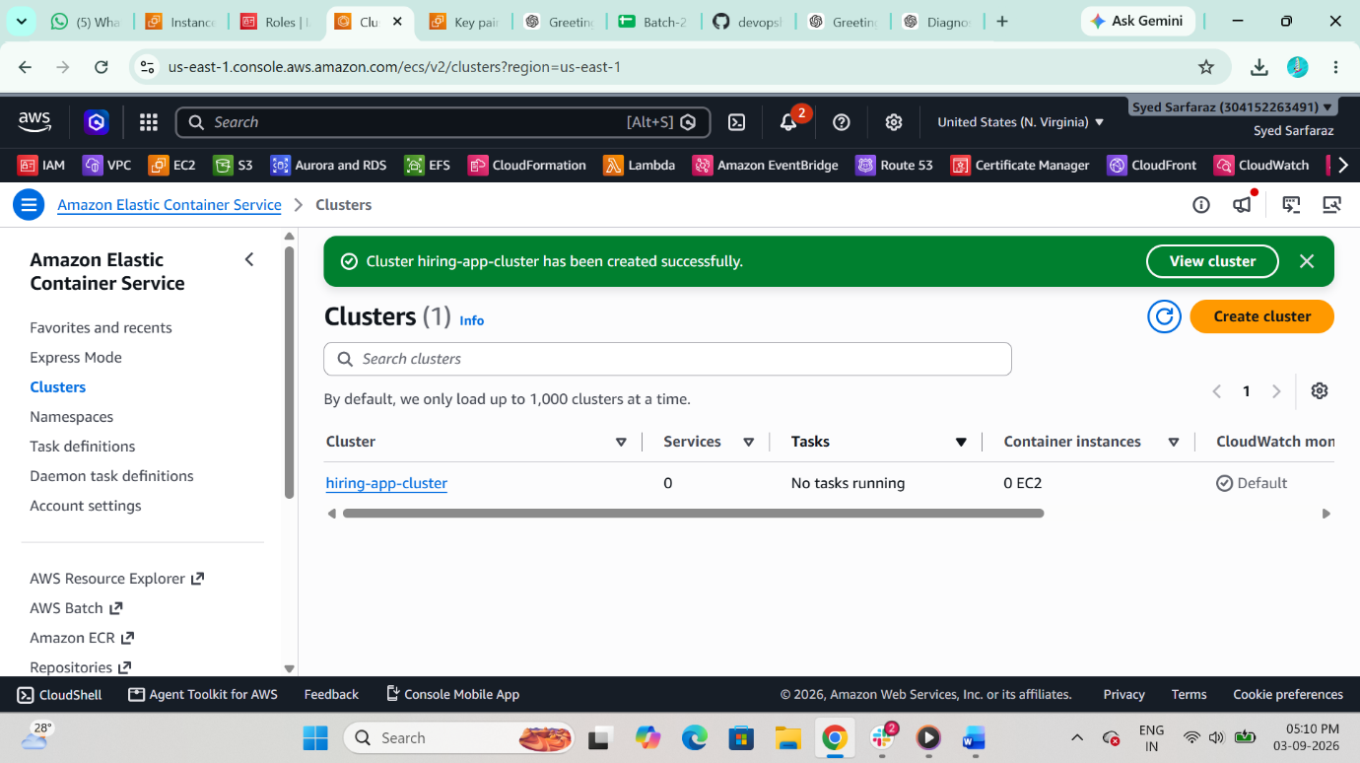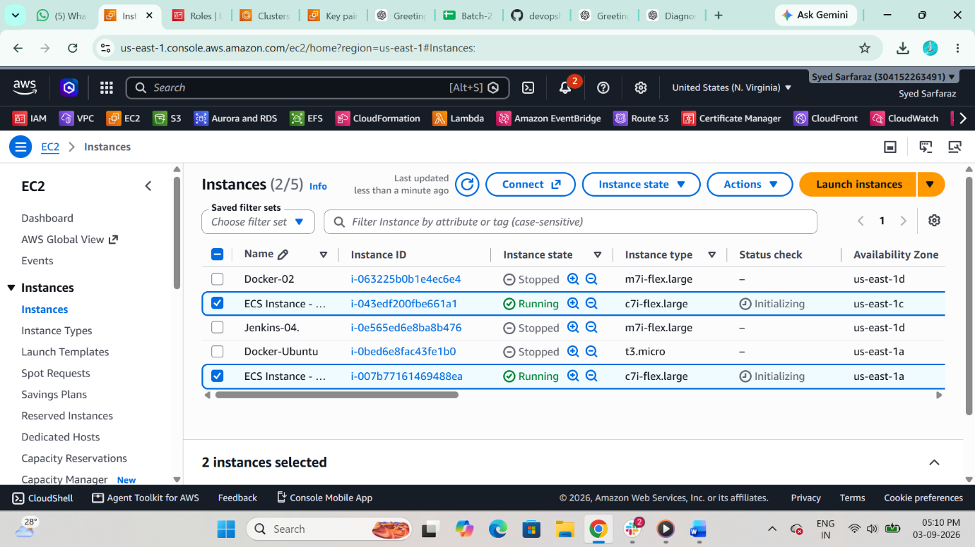

STEP 10: Create Task Definition
• ECS → Task Definitions → Create
• Family: hiring-app-task-definition
• Launch type: EC2
• Network mode: bridge
• CPU: 0.5 vCPU
• Memory: 1GB
Container
• Name: hiring-app
• Image: sabair0509/hiring-app:works
• Container port: 8080
• Host port: 0 (Dynamic port mapping)
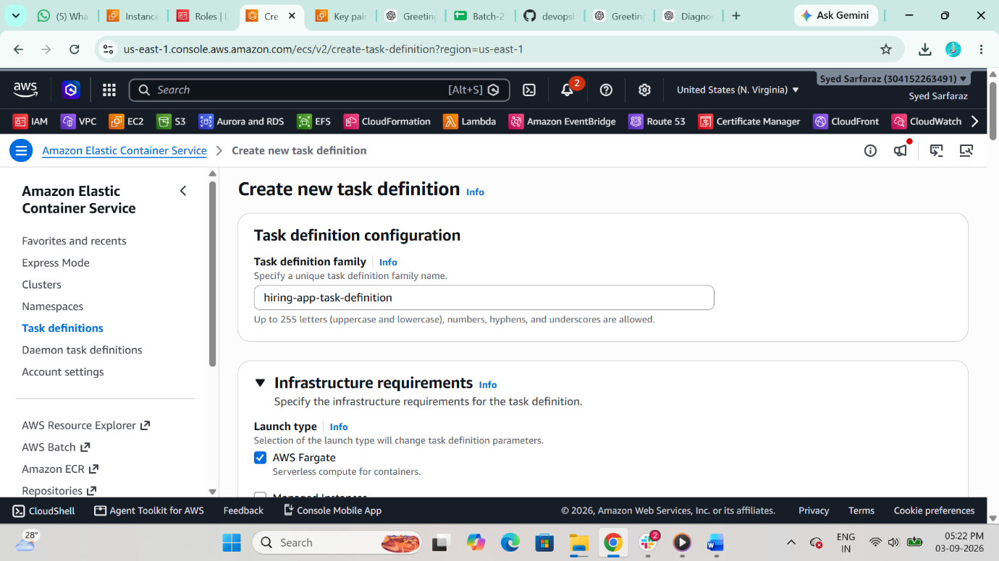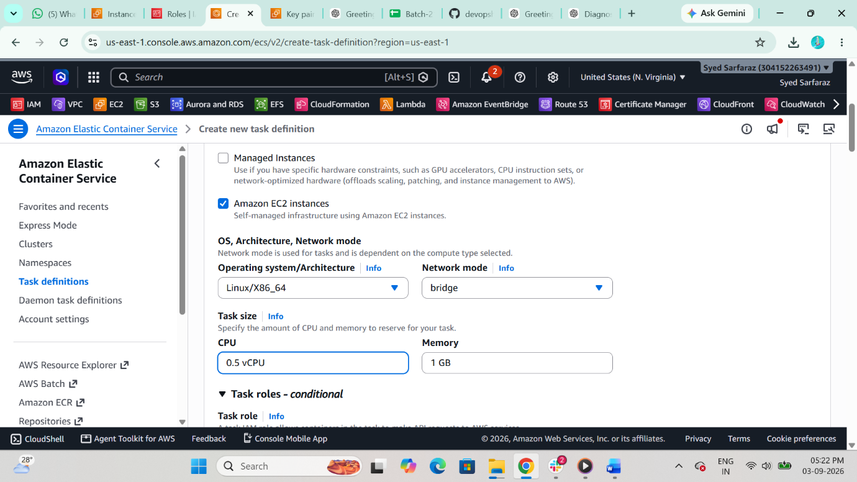
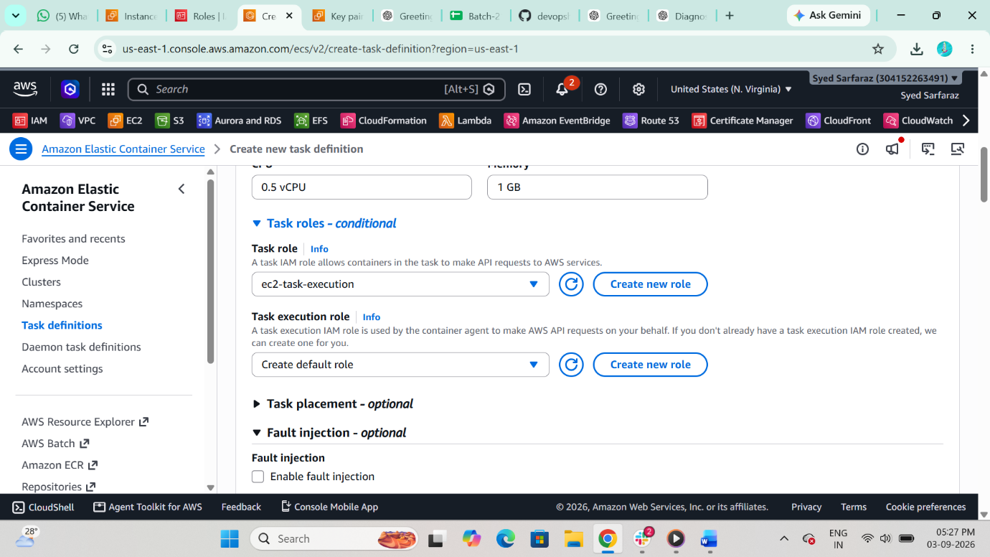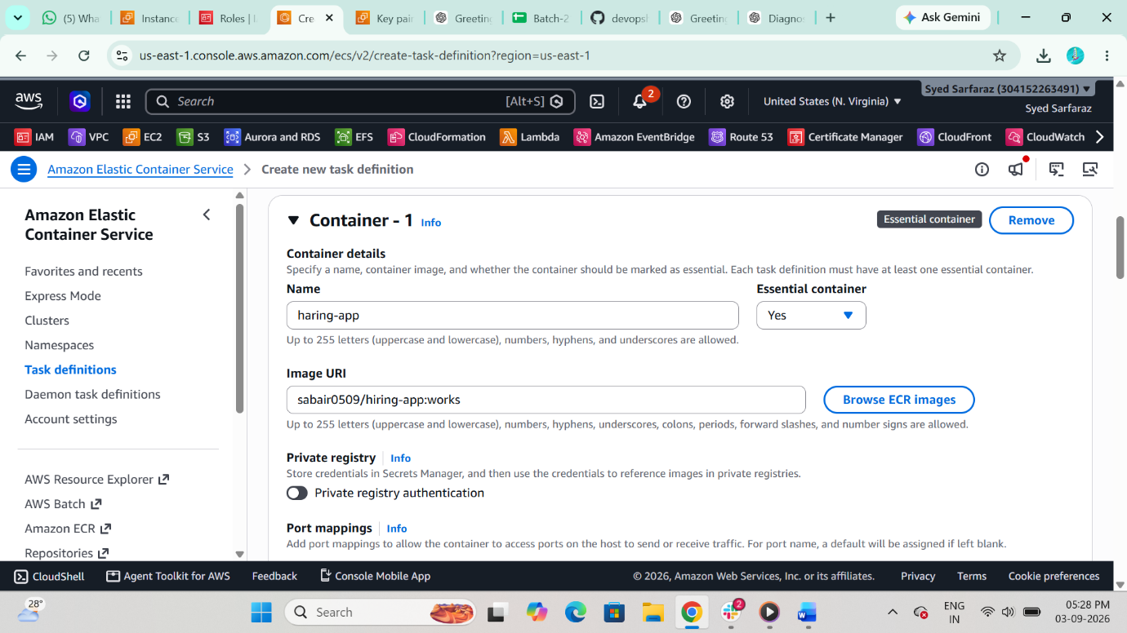
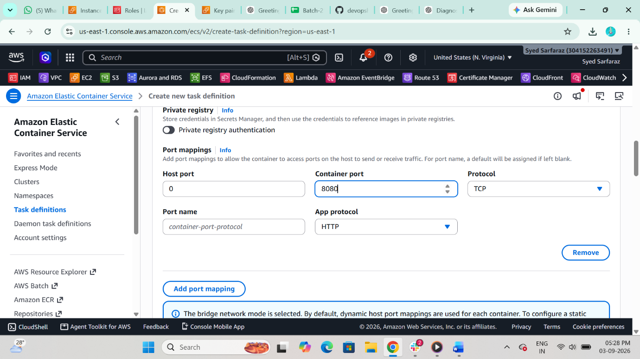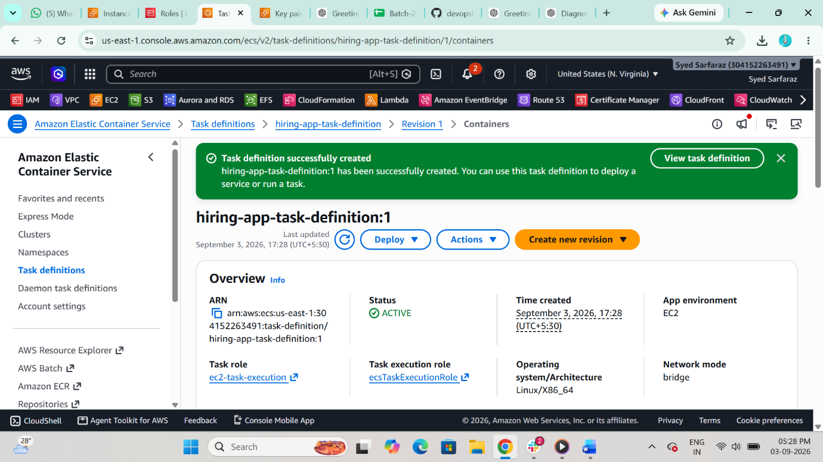
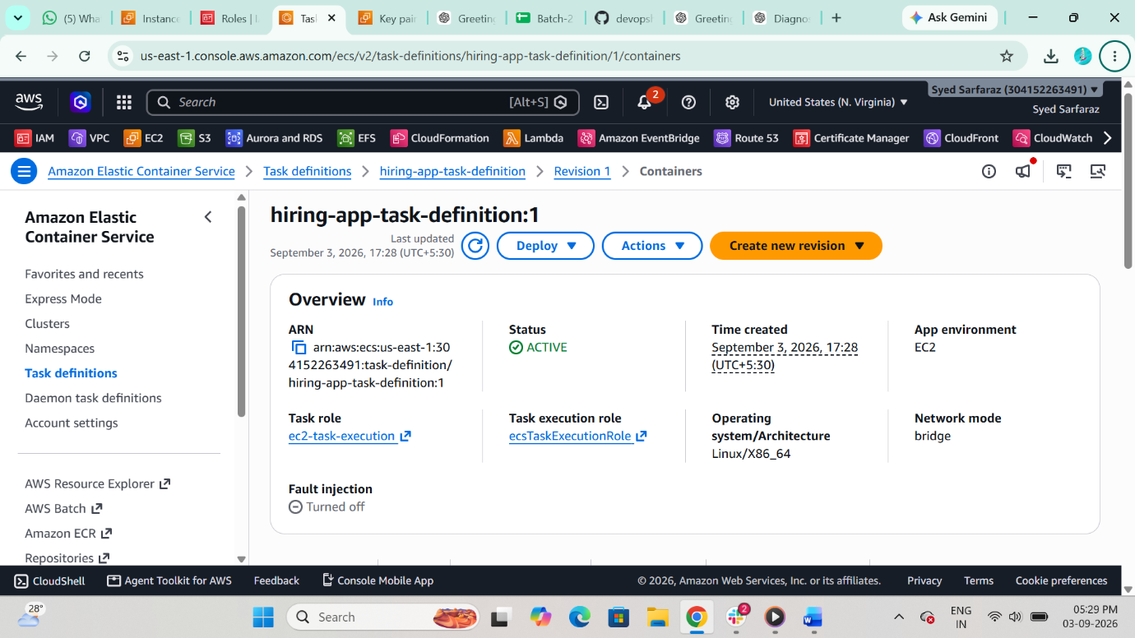

STEP 11 Create Target Group
• EC2 → Target Groups → Create
• Type: Instances
• Protocol: HTTP
• Port: 80
• Health check path: /
• Success codes: 200-499
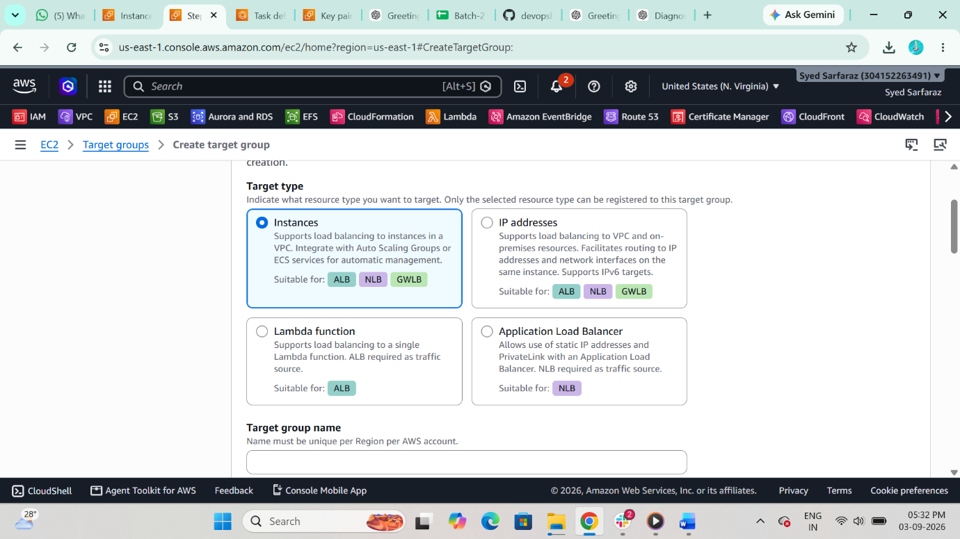
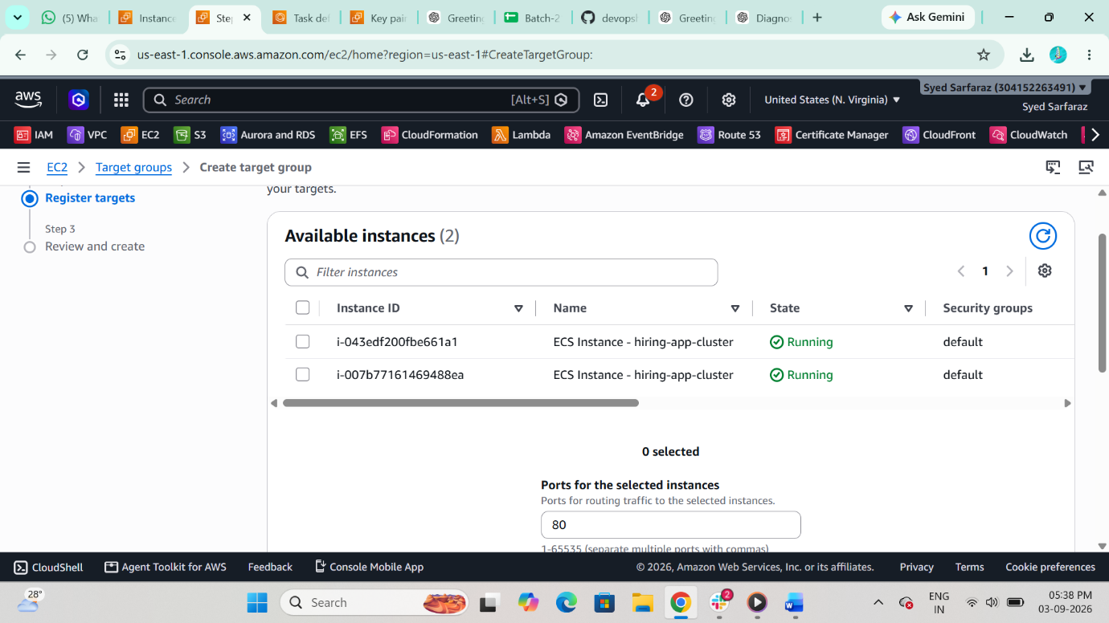
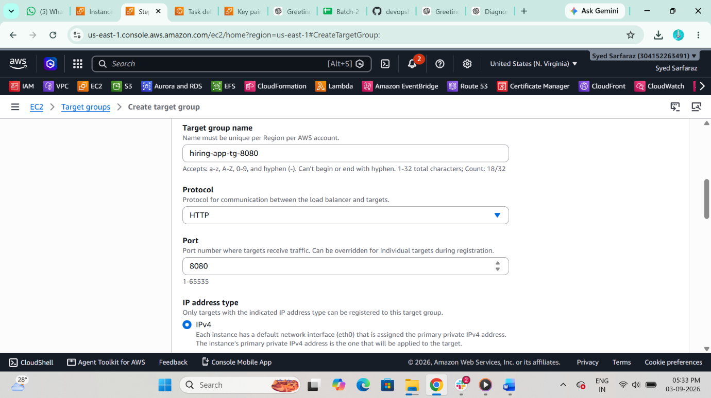
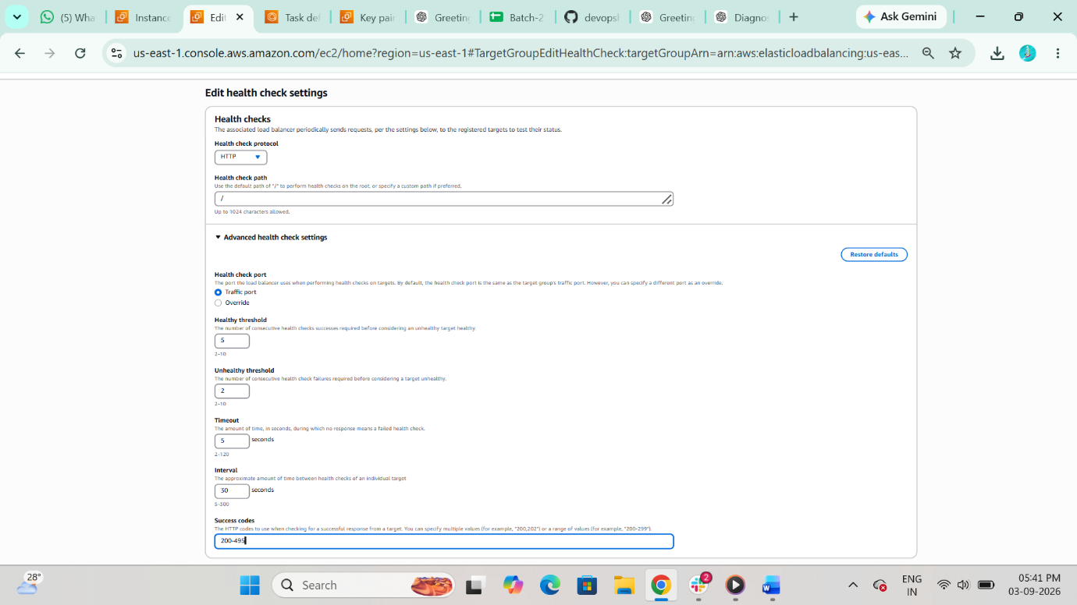

STEP 12 Create Application Load Balancer
• EC2 → Load Balancers → Create ALB
• Name: hiring-alb
• Scheme: Internet-facing
• Select 2 subnets (Multi-AZ)
• Listener: HTTP 80
• Forward to target group
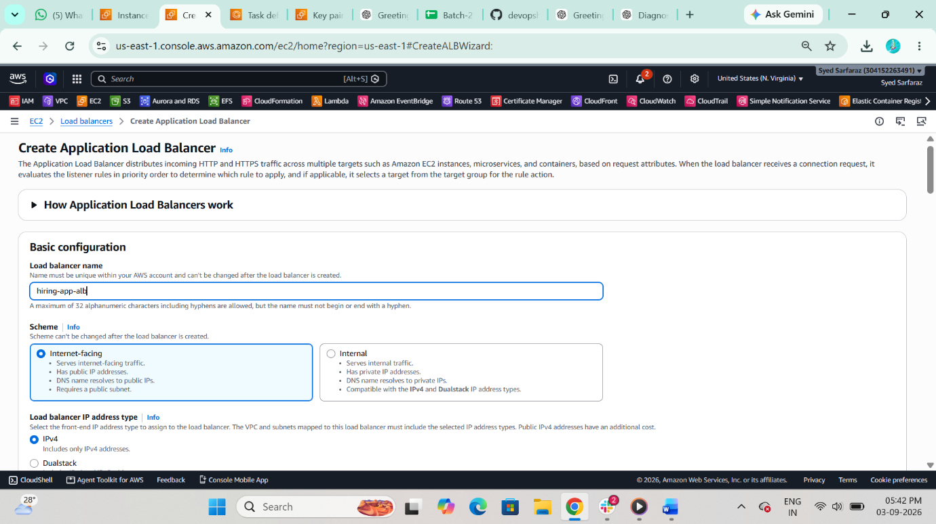
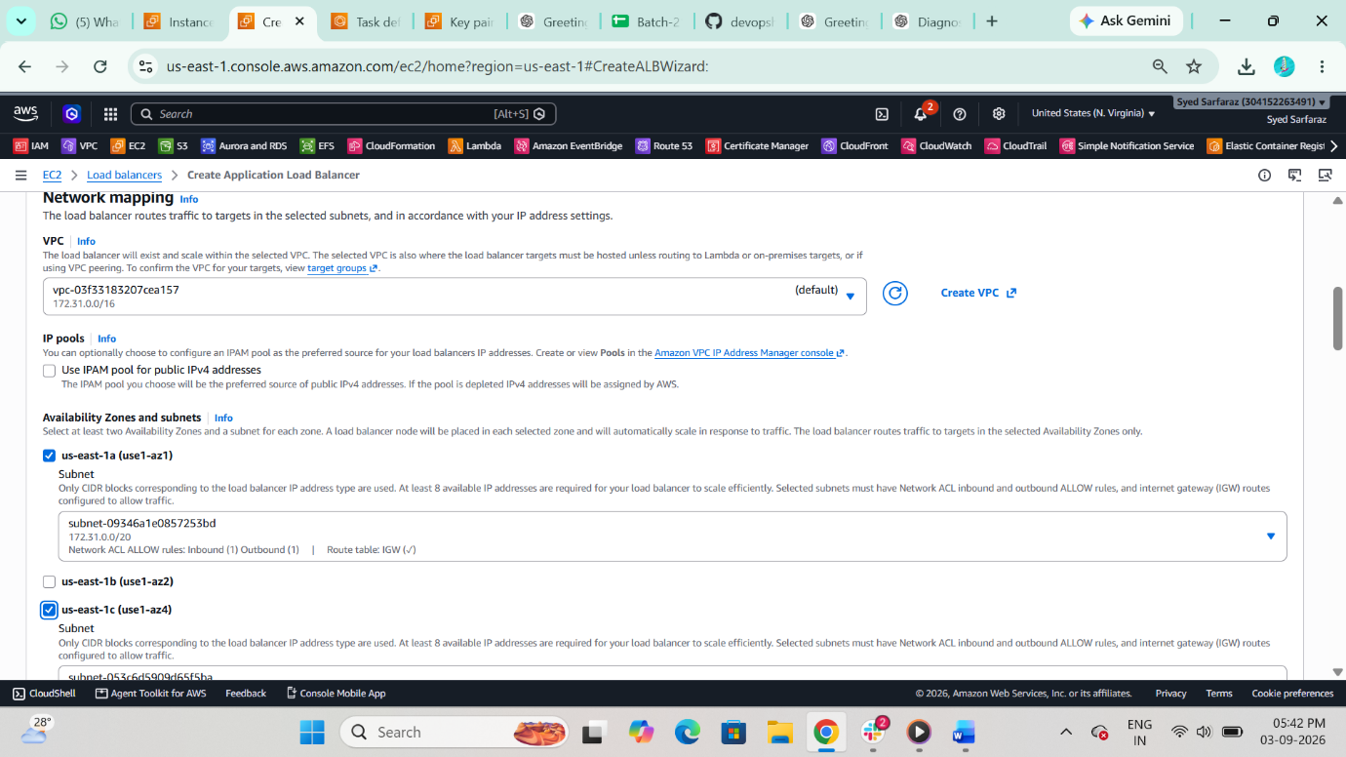
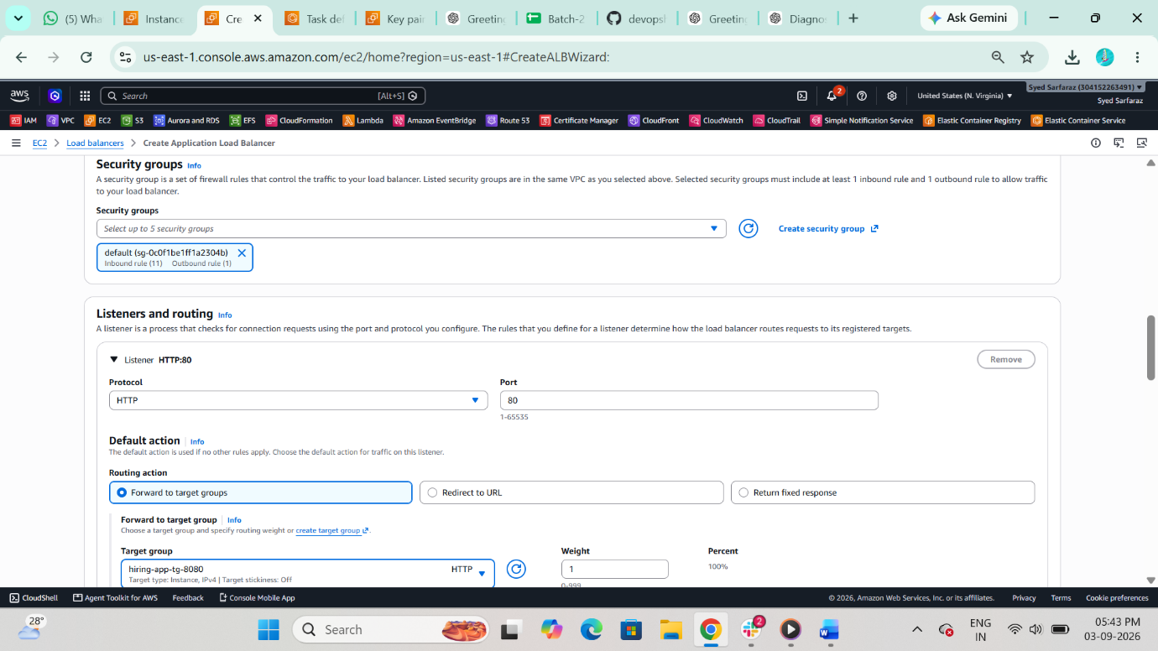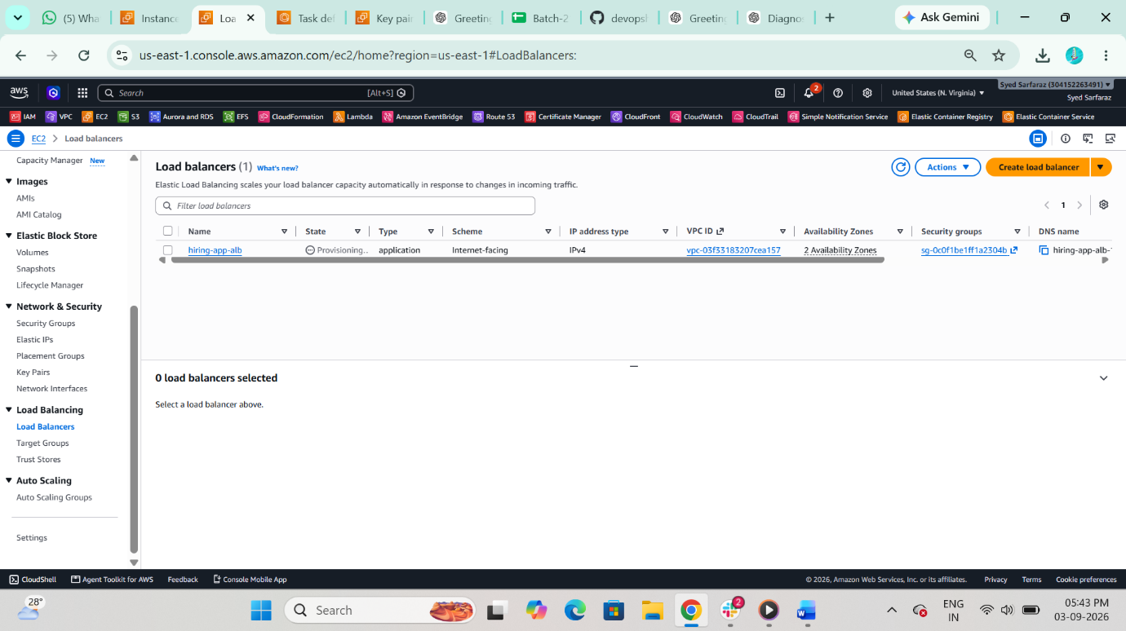

STEP 13 Create ECS Service
• Cluster → Create Service
• Task definition: Latest
• Service name: hiring-app-service
• Launch type: EC2
• Desired tasks: 6
• Deployment type: Rolling update
Load Balancing
• Use existing ALB
• Select target group
• Container: hiring-app
• Port: 8080

Step 7: Enable Auto Scaling
• Minimum tasks: 6
• Maximum tasks: 12
• Policy: Target Tracking
• Metric: ECSServiceAverageCPUUtilization
• Target: 70%
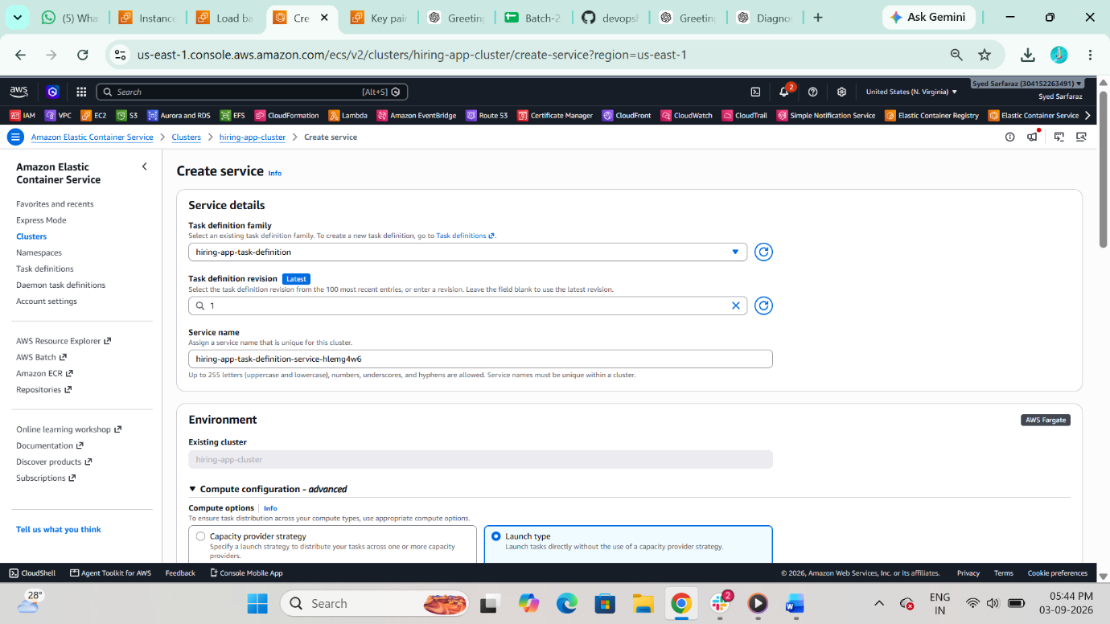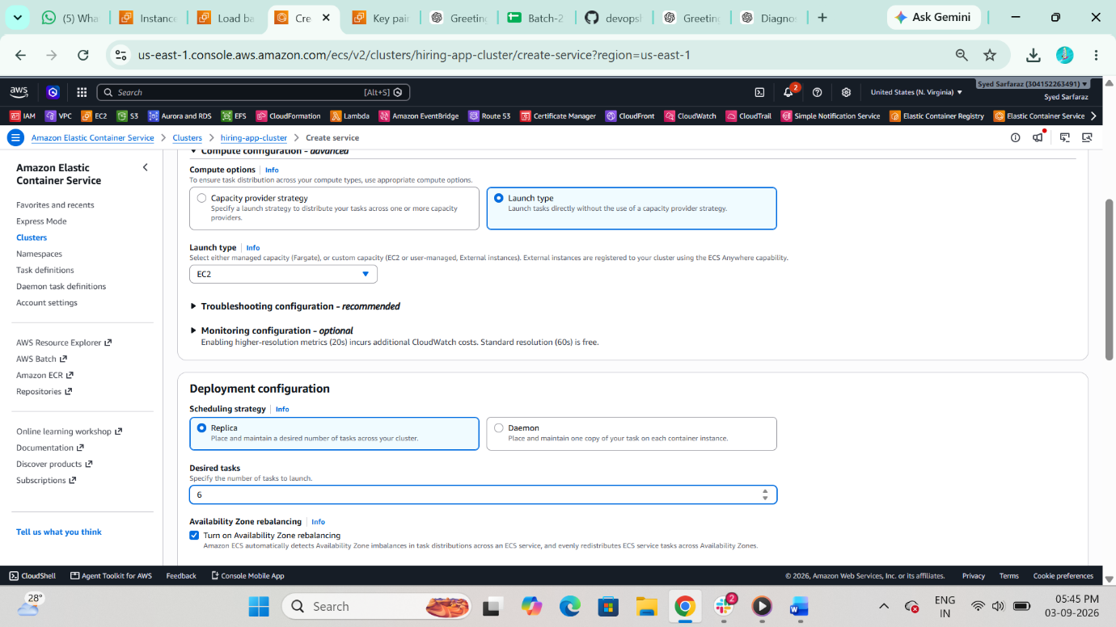
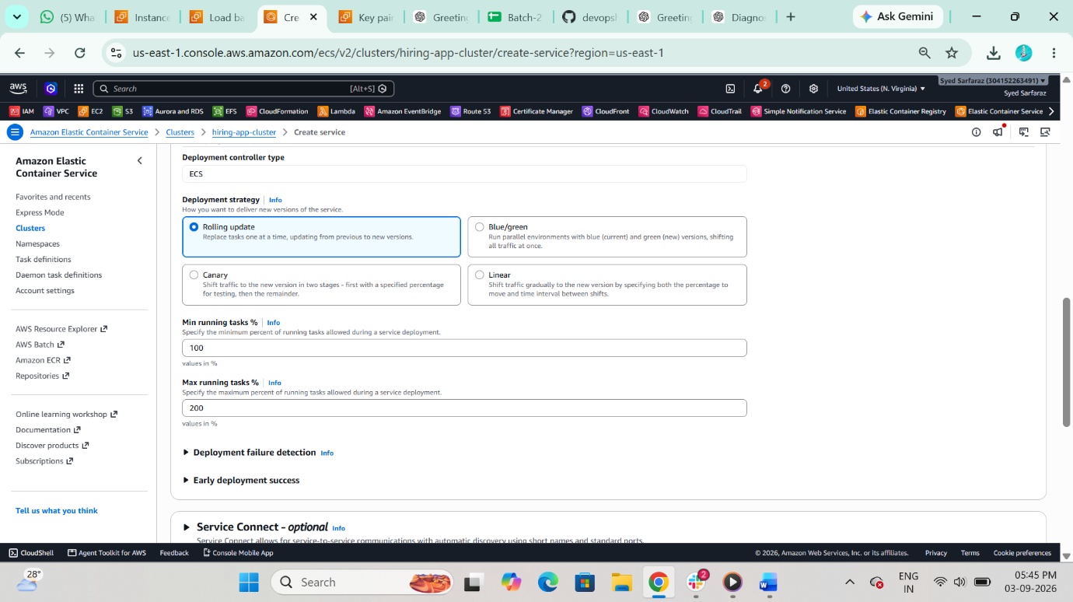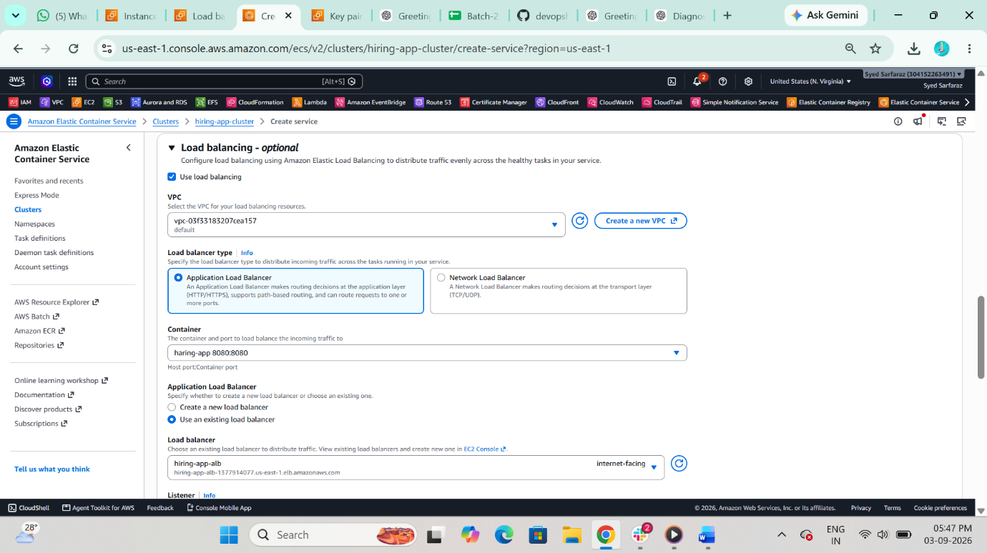
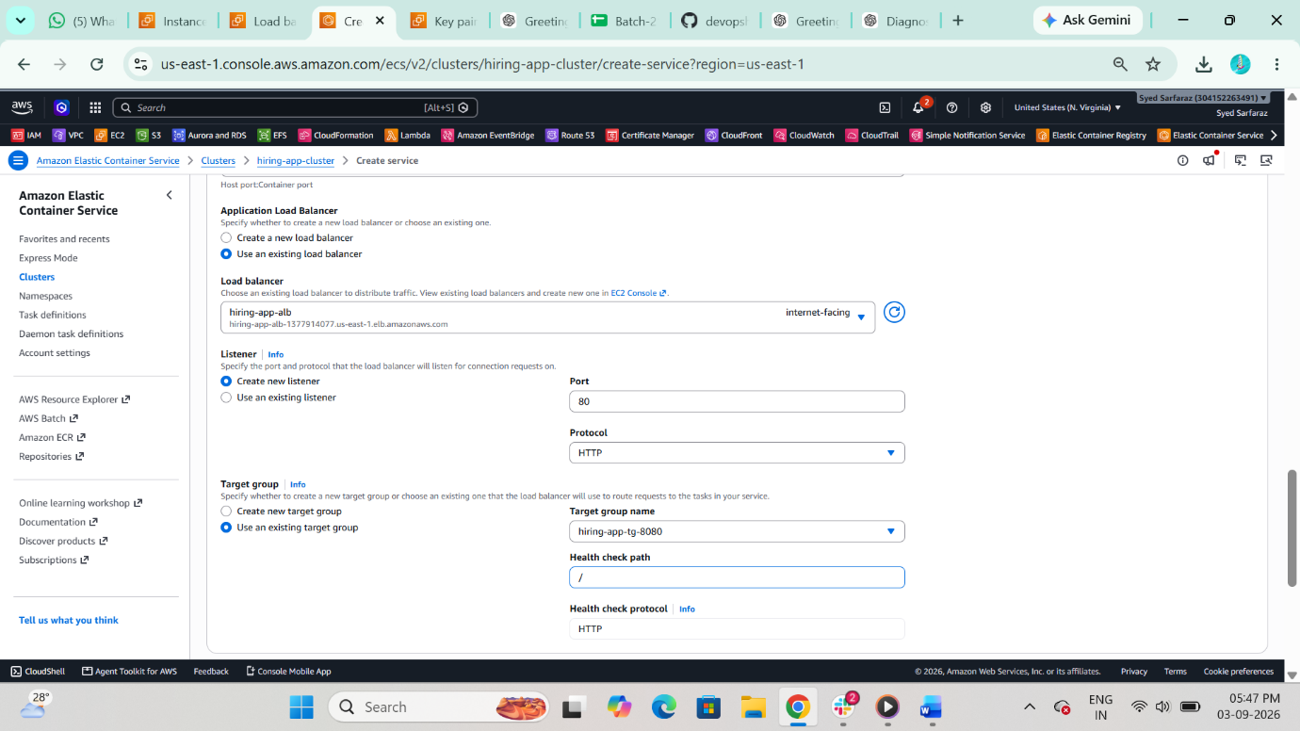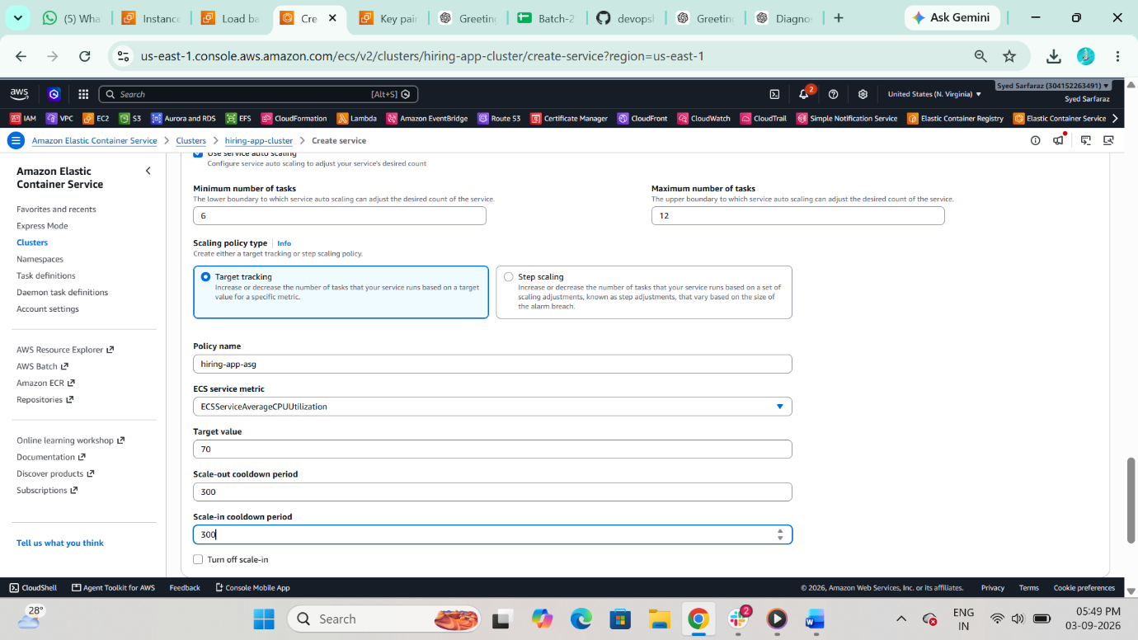
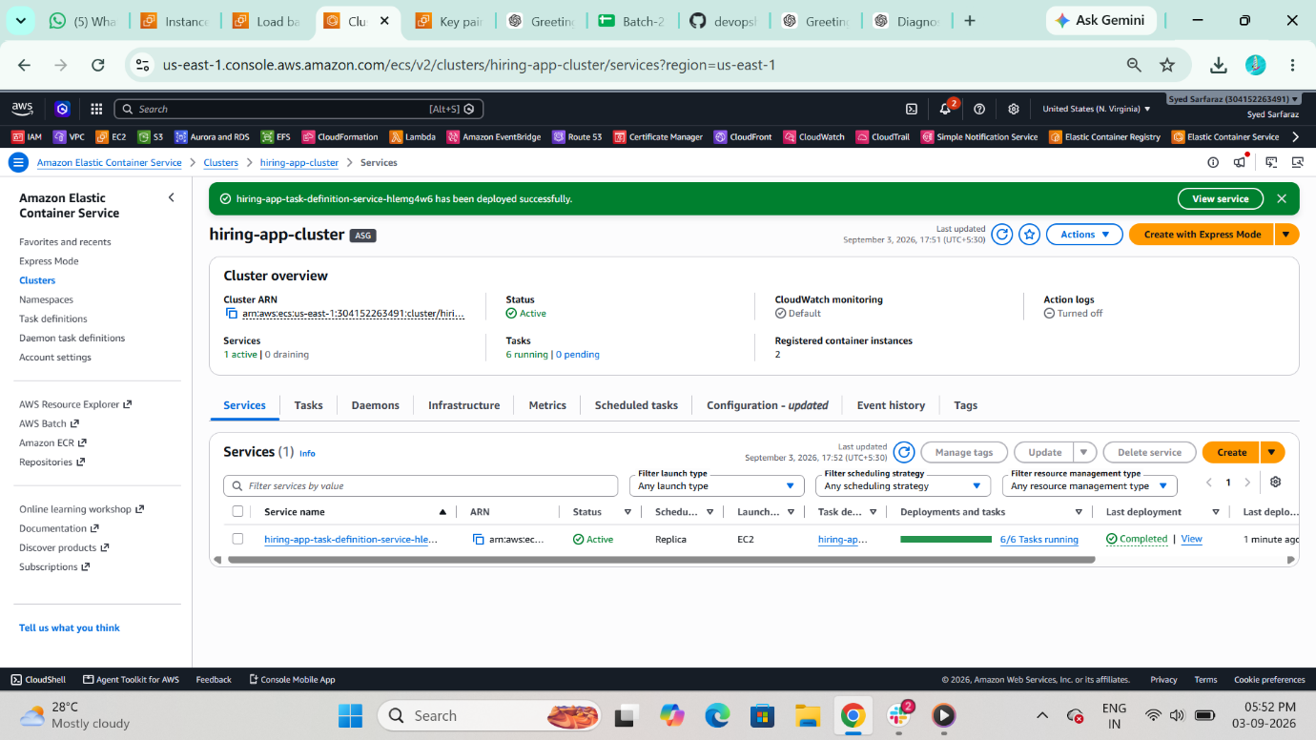

Result
• 6 tasks always running
• Tasks distributed across multiple AZs
• ALB distributes traffic
• Dynamic port mapping enabled
• Highly available architecture achieved